**Kratin Usecase**

In this system, users can register and log in to an application developed using React JS for the front end, Java EE for the back end, and MySQL for the database. Once registered and logged in, users can enter their data, and based on that data, the system provides recommendations. The system also displays nearby hospitals and laboratories along with their contact numbers.

The system follows the following Workflow

1.User Registration:

Users who are new to the system need to register by providing their details such as email and password.

2.User Login:

Registered user can login to application using their email and password.

3.Data Entry:

After successful login, users can enter their data, which will be used to provide personalized recommendations.

4.Recommendation Generation:

Based on the entered data, the system generates recommendations tailored to the user’s needs and preferences.

5.Display of Doctors and Laboratories:

The system also displays a list of doctors and laboratories, along with their contact numbers, to provide users with relevant healthcare options.

The technology stack used in this project includes React JS for the frontend, java EE for the backend and MySQL for the database.

Overall, this system aims to assist users in making informed decisions about their healthcare by providing personalized recommendations and access to relevant medical professionals and facilities.

Following are the screen shots:

1.Sign In:-

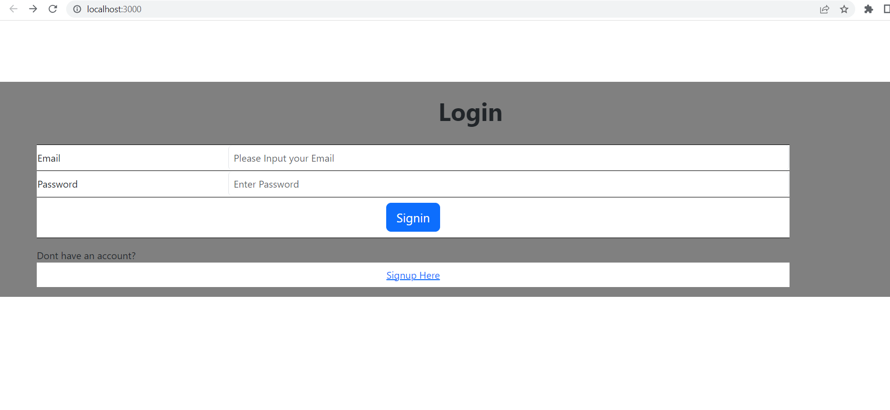

2. Sign Up Page:-

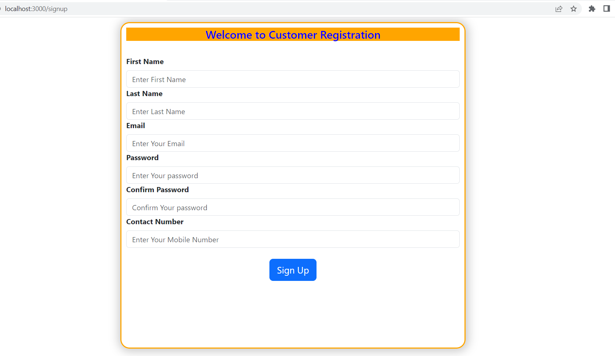

3.Dashboard:-

